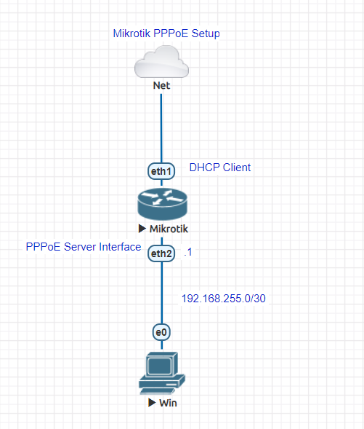

Mikrotik Router Script Configuration

TASK DONE

1. Design Topology (Pick Node device, Arrangement, connection and Label)
2. Configure Mikrotik (Router id, Password, Welcome note, Interface rename, IP addressing, DNS, Firewall NAT, Pool, PPPoE Server, Secret and Profile, Queues)
3. Setup Client (Computer)